Efficiency begins with planning your loads ahead of arrival to a Beltrami County Facility.

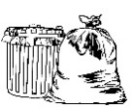
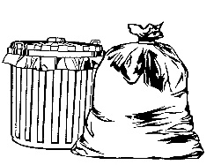
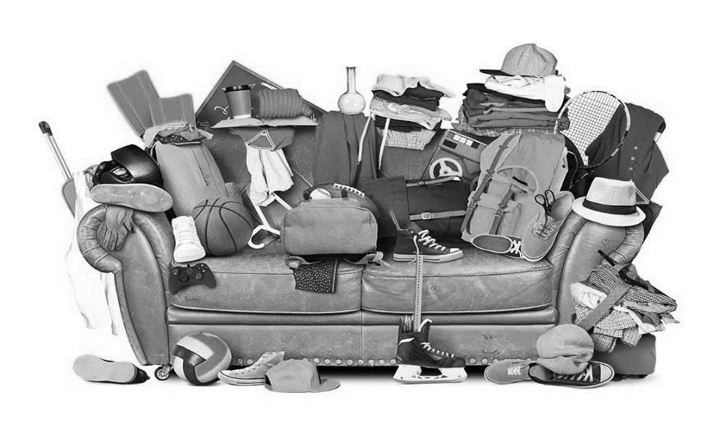

Scrap Metal

Recycle –
Household Garbage –
Non-Burn –
Scrap Metal – On top of your load if going to the Bemidji Transfer Station since it’s your first stop, and at the bottom of your load at the Blackduck/Kelliher Transfer Station since it’s your last stop.

